LAB 02
SRN: PES1UG24CS712

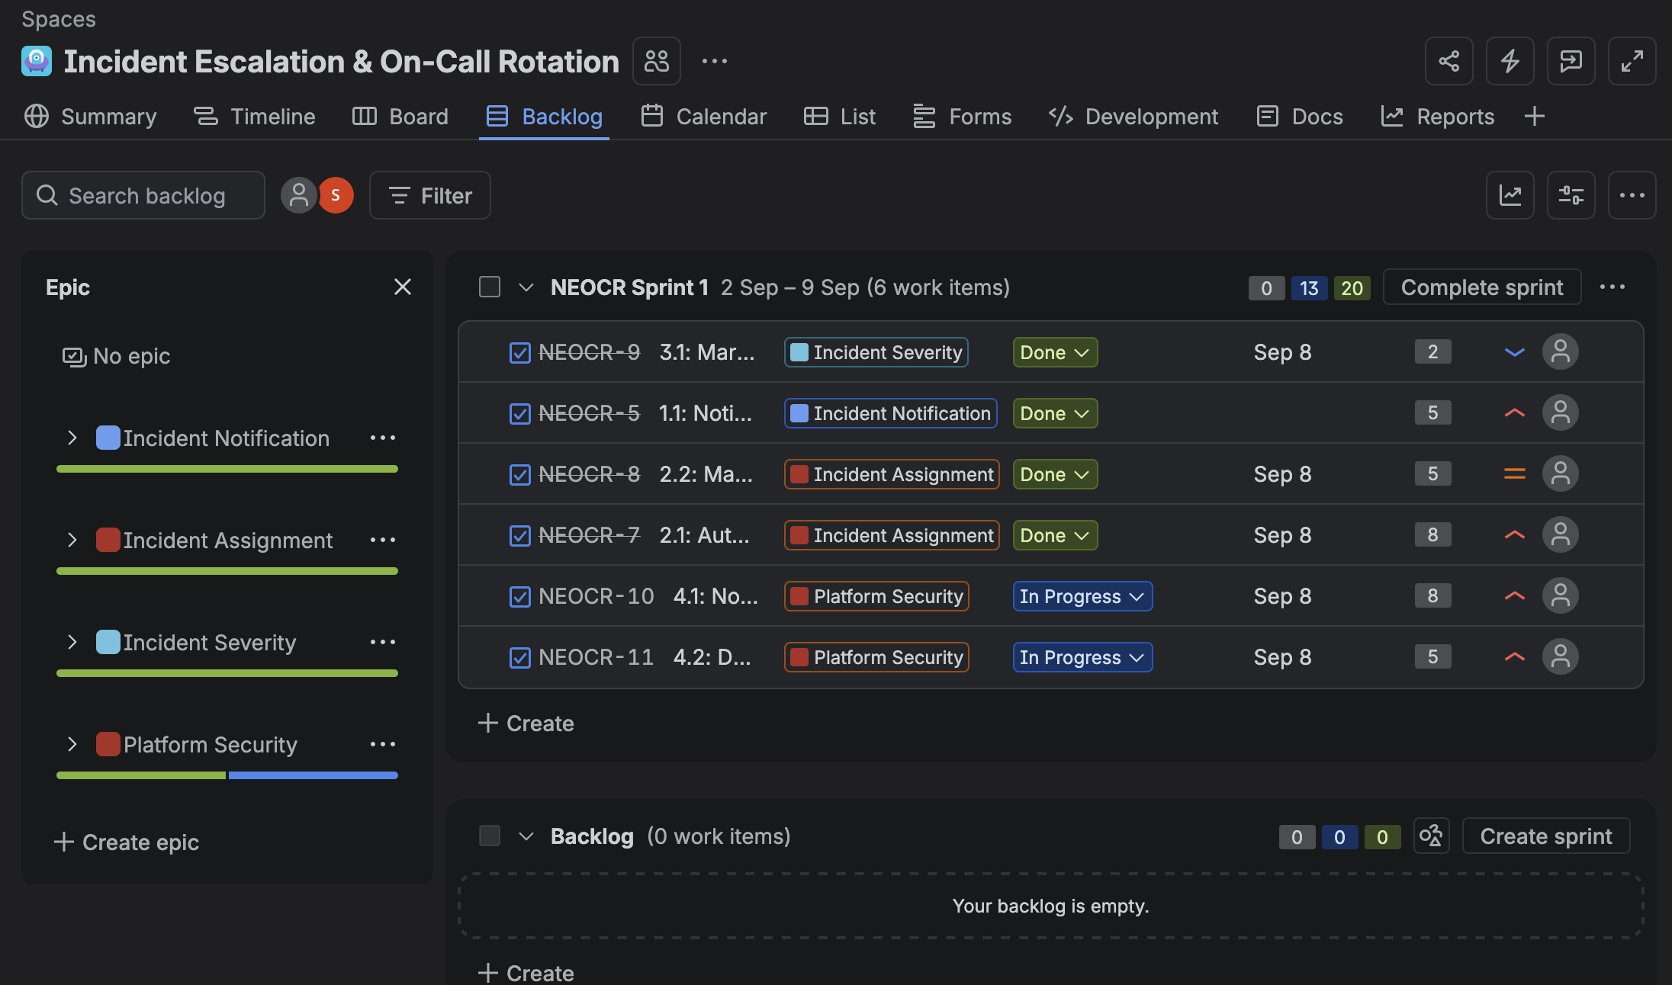

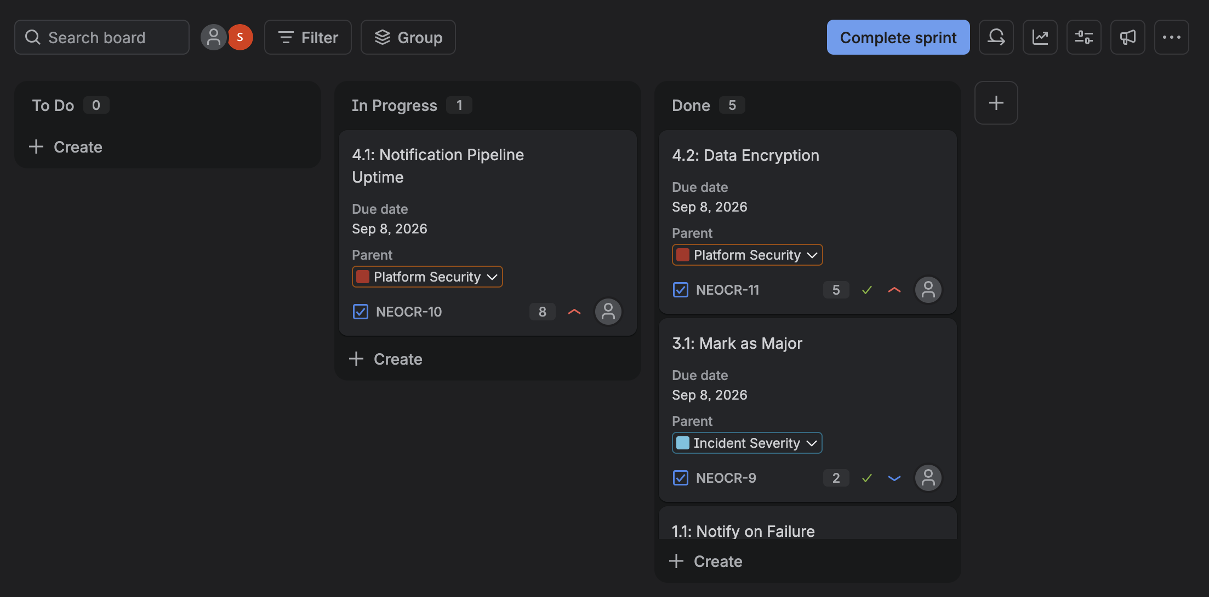

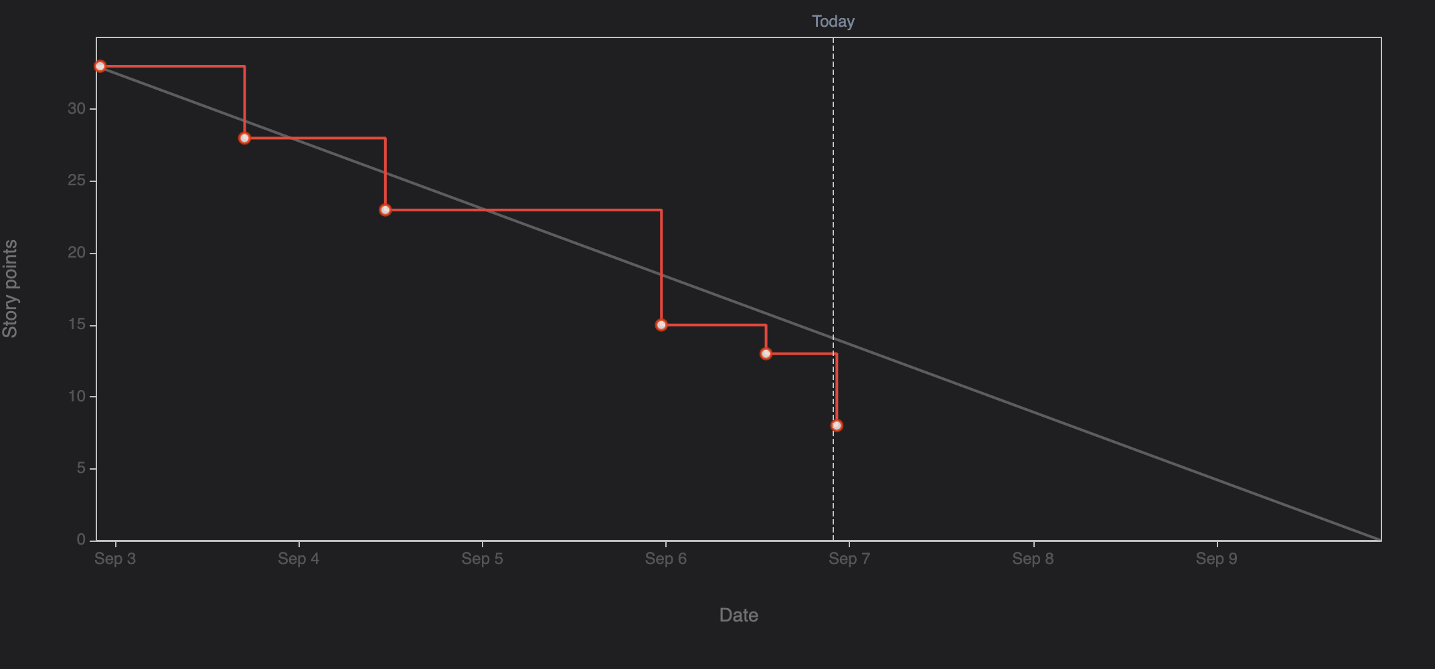

Reflection Questions
- The estimation of the stories through story points were definitely helpful however it is impossible to correctly predict the difficulty of a task.
- The backlog was well prioritized. However, the sprint had to be cut short due to time-constraints
- The ideal sprint line and the actual sprint seem to be aligned for the most part leading one to believe that the tasks were completed on time
- The team is more than capable of handling even more complex tasks. However, it is a delicate balance. An ideal balance of handling tasks should be maintained as having too many tasks would be counter-productive in the long run

